**17**

**Superposition and Standing Waves**

|  |
| --- |
| **CHAPTER OUTLINE** |

17.1 Analysis Model: Waves in Interference

17.2 Standing Waves

17.3 Boundary Effects: Reflection and Transmission

17.4 Analysis Model: Waves Under Boundary Conditions

17.5 Resonance

17.6 Standing Waves in Air Columns

17.7 Beats: Interference in Time

17.8 Nonsinusoidal Wave Patterns

* An asterisk indicates a question or problem new to this edition.

|  |
| --- |
| **SOLUTIONS TO THINK-PAIR-SHARE AND ACTIVITIES** |

**\*TP17.1 Conceptualize** Look at your guitar, if you own one, or an image online, and notice that standard guitars have six strings and that the vibrating portions of all the strings are the same length. The table in the problem statement provides data for each of the six strings.

**Categorize** The wave on each of the strings of the guitar is modeled as a *wave under boundary conditions,* such that standing waves will be set up on the strings when they are plucked.

**Analyze** An inconvenience is that guitar string data are usually not given in metric units. So, for example, we will need to convert the scale length of the string to meters:



We will also need to convert the linear mass density to kg/m, for example, for the e’-string:



Applying this conversion to the linear mass densities gives us the results in the following table:

|  |  |  |  |
| --- | --- | --- | --- |
| **Open String Note** | **Fundamental Frequency (Hz)** | **String weight/unit length (10–5 lb/in)** | **String mass/unit length (10–4 kg/m)** |
| e’ | 329.6 | 2.000 | 3.572 |
| b | 246.9 | 2.930 | 5.232 |
| g | 196.0 | 5.870 | 10.48 |
| d | 146.8 | 9.180 | 16.39 |
| A | 110.0 | 14.70 | 26.25 |
| E | 82.41 | 32.20 | 57.50 |

(a) The waves under boundary conditions model leads to Equation 17.7 for the fundamental frequency *f*1 of a string. This equation can be solved for the tension in the string, leading to

 (1)

Using this equation to find the tension in each of the six guitar strings leads to the following table:

|  |  |  |  |
| --- | --- | --- | --- |
| **Open String Note** | **Fundamental Frequency (Hz)** | **String mass/unit length (10–4 kg/m)** | **Tension in String (N)** |
| e’ | 329.6 | 3.572 | 65.12 |
| b | 246.9 | 5.232 | 53.52 |
| g | 196.0 | 10.48 | 67.56 |
| d | 146.8 | 16.39 | 59.27 |
| A | 110.0 | 26.25 | 53.30 |
| E | 82.41 | 57.50 | 65.53 |
|  |  | **Total:** | **364.3** |

Adding up the values of the tension in the right column of the table above gives *T*total = 364 N for the total tension exerted by all the strings.

(b) Using Equation 16.18 to find the wave speed on the strings gives us the following table:

|  |  |  |  |  |
| --- | --- | --- | --- | --- |
| **Open String Note** | **Fundamental Frequency (Hz)** | **String mass/unit length (10–4 kg/m)** | **Tension in String (N)** | **Wave Speed (m/s)** |
| e’ | 329.6 | 3.57 | 65.2 | 427 |
| b | 246.9 | 5.23 | 53.6 | 320 |
| g | 196 | 10.5 | 67.6 | 254 |
| d | 146.8 | 16.4 | 59.3 | 190 |
| A | 110 | 26.3 | 53.4 | 143 |
| E | 82.4 | 57.5 | 65.6 | 107 |

The ratio of the wave speeds for the highest-frequency and lowest-frequency strings is



The ratio exactly agrees with your design criterion.

(c) Now consider the question in part (c) in light of Equation 16.12:



Because all of the strings on the guitar have the same length, they will all have the same fundamental wavelength **. Therefore, the wave speed in a particular string is proportional to the fundamental frequency of the string. Because the highest and lowest open strings play notes that are two octaves apart, the ratio of fundamental frequencies has to be *exactly* 4. Therefore, the design criterion is met by *all* guitars with strings that have equal lengths!

**Finalize** In part (a), notice that the tensions all reside in a relatively narrow range. This is a good design, since for example, an increasing tension as you go from one string to the next could exert a possibly dangerous torque on the bridge of the guitar.

Answer: (a) 364 N (b) yes (c) no

**\*TP17.2** Answers:When the bottles are struck, the glass vibrates. Increasing levels of water provide more mass loading to the vibrations, and the frequency goes *down*. When you blow in the bottles, the air column above the water vibrates. Increasing levels of water shortens the length of the air column, and the frequency goes *up*.

**\*TP17.3** What you are hearing is a type of sound called a *combination tone*. The ear is a nonlinear device, which means that it does not reproduce the input signal as a pure sine wave. It will generate harmonics of the sine wave, so that the sound is a combination of frequencies like Eq. 17.14. If one of the sine wave sounds is generated at frequency *f*1, your ear will *generate,* due to its nonlinearity, and *detect* a mixture of frequencies of the form *nf*1, where *n* is an integer. Your ear will do the same thing to the other sound of frequency *f*2, so you will hear a mixture of frequencies of the form *mf*2, where *m* is another integer. Because both sounds are playing at the same time, they combine by the principle of superposition. The nonlinearity of your ear then generates additional frequencies, equal to all possible combinations



A simple combination to hear is that for which *n* = *m* = 1 and we choose the minus sign:



This is the combination tone that we call the *beat frequency,* seen in Equation 17.13. The beat frequency will begin at 200 Hz and rise to 1 000 Hz.

Another relatively easy combination tone to hear is



which is a beat frequency between the second harmonic of the first tone and the fundamental of the second. This one is much higher: it begins at 4 200 Hz and rises to

5000 Hz.

Answer: The upward-moving sound is the *beat frequency.*

|  |
| --- |
| **SOLUTIONS TO END-OF-CHAPTER PROBLEMS** |

**Section 17.1 Analysis Model: Waves in Interference**

**P17.1** The superposition of the waves is given by



evaluated at the given x values.

(a) At x = 1.00, t = 1.00, the superposition of the two waves gives



(b) At x = 1.00, t = 0.500, the superposition of the two waves gives



(c) At x = 0.500, t = 0, the superposition of the two waves gives



**P17.2** (a) The graph at time *t* = 0.00 seconds is shown in ANS. FIG. P17.2 (a)

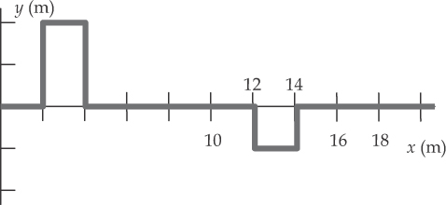

**ANS. FIG. P17.2(a)**

The pulse initially on the left will move to the right at 1.00 m/s, and the one initially at the right will move toward the left at the same rate, as follows:

ANS. FIG. P17.2 (b) shows the pulses at time *t* = 2.00 seconds

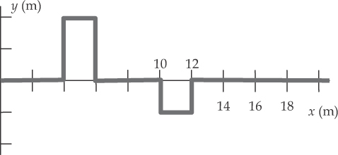

ANS. FIG. P17.2(b)

ANS. FIG. P17.2 (c) shows the waves at time *t* = 4.00 seconds, immediately before they overlap.

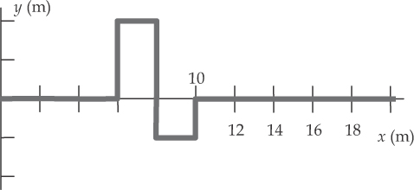

**ANS. FIG. P17.2 (c)**

ANS. FIG. P17.2 (d) shows the pulses at time *t* = 5.00 seconds, while the two pulses are fully overlapped. The two pulses are shown as dashed lines.

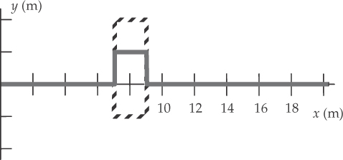

**ANS. FIG. P17.2 (d)**

ANS. FIG. P17.2 (e) shows the pulses at time At time *t* = 6.00 seconds, immediately after they completely pass.

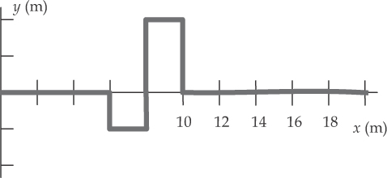

**ANS. FIG. P17.2 (e)**

(b) If the pulse to the right is inverted, ANS. FIG. P17.2 (f) shows the pulses at time *t* = 0.00 seconds.

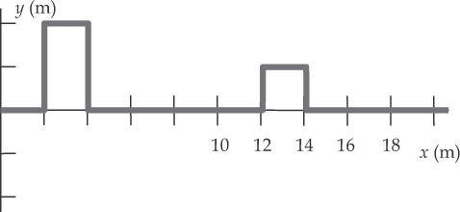

**ANS. FIG. P17.2 (f)**

The pulse initially on the left will move to the right at 1.00 m/s, and the one initially at the right will move toward the left at the same rate, as follows:

ANS. FIG. P17.2 (g) shows the two pulses at time *t* = 2.00 seconds

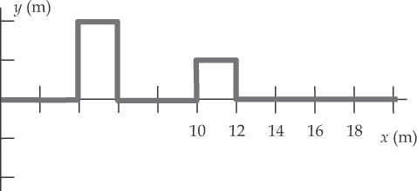

**ANS. FIG. P17.2 (g)**

ANS. FIG. P17.2 (h) shows the two pulses at time *t* = 4.00 seconds, immediately before they overlap.

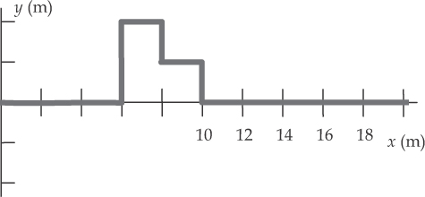

**ANS. FIG. P17.2 (h)**

ANS. FIG. P17.2 (i) shows the two pulses at time *t* = 5.00 seconds, while the two pulses are fully overlapped. The two pulses are shown as dashed lines.

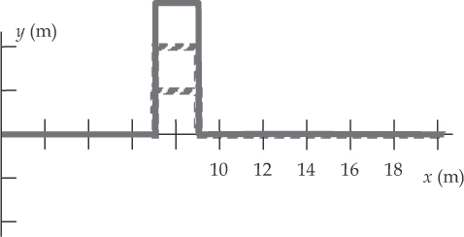

**ANS. FIG. P17.2 (i)**

ANS. FIG. P17.2 (j) shows the two pulses at time *t* = 6.00 seconds, immediately after they completely pass.

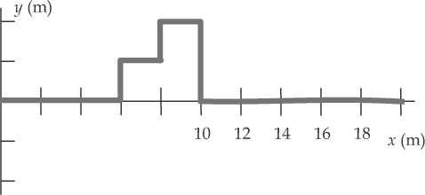

**ANS. FIG. P17.2 (j)**

**P17.3** ANS. FIG. P17.3 shows the sketches at each of the times.

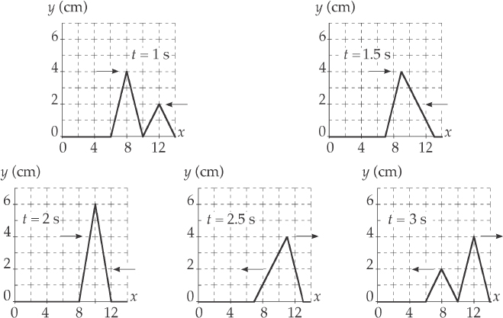

**ANS. FIG. P17.3**

**P17.4** Consider the geometry of the situation shown on the right.  
The path difference for the sound waves at  
the location of the man is

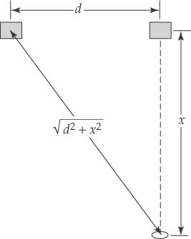

ans. FIG. P17.4****



For a minimum, this path difference must equal

a half-integral number of wavelengths:



Solve for x:



In order for x to be positive, we must have



Substitute numerical values:



The only values of n that satisfy this requirement are n = 0 and n = 1.

Therefore,



**P17.5** (a) At constant phase, *φ* = 3*x –* 4*t* will be constant. Then  will change: the wave moves. As *t* increases in this equation, *x* increases, so the first wave moves to the right, in the .

In the same way, in the second case  As *t* increases, *x* must decrease, so the second wave moves to the left, in the .

(b) We require that *y*1 + *y*2= 0.



This can be written as

(3*x* − 4*t*)2 = (3*x +* 4*t* − 6)2

Solving for the positive root, 8*t* = 6, or



(c) The negative root yields

(3*x* − 4*t*) = –(3*x +* 4*t* − 6)

The time terms cancel, leaving . At this point, the waves **always** cancel.

**P17.6** (a) First we calculate the wavelength: 

Then we note that the path difference equals





(b) We choose the origin at the midpoint between the speakers. If the receiver is located at point (x, y), then we must solve:



Then,



Square both sides and simplify to get



Upon squaring again, this reduces to

 

Substituting, *λ* = 16.0 m, and reducing,



Note that the equation 9.00*x*2 – 16.0*y*2 = 144 represents two hyperbolas: one passes through the x axis at x = +4.00 m; the second, which is the mirror image of the first, passes through   
x = –4.00 m to the left of the y axis.

(c) Solve for y in terms of x:



Then



For very large x, the square root term approaches 1:



To the right of the origin, for large x the hyperbola approaches the shape of a straight line above and below the x axis.



**P17.7** At any time and place, the phase shift between the waves is found by subtracting the phases of the two waves, Δ*φ* = *φ*1 − *φ*2.

Δ*φ* = (20.0 rad/cm)*x* − (32.0 rad/s)*t*

− [(25.0 rad/cm)*x* − (40.0 rad/s)*t*]

Collecting terms,

Δ*φ* = −(5.00 rad/cm)*x* + (8.00 rad/s)*t*

(a) At *x* = 5.00 cm and *t* = 2.00 s, the phase difference is

Δ*φ* = (−5.00 rad/cm)(5.00 cm) + (8.00 rad/s)(2.00 s)



(b) The sine functions repeat whenever their arguments change by an integer number of cycles, an integer multiple of 2*π* radians. Then the phase shift equals ±*π* whenever Δ*φ* = *π* + 2*nπ*, for all integer values of *n*. Substituting this into the phase equation, we have

*π* + 2*nπ* = −(5.00 rad/cm)*x* + (8.00 rad/s)*t*

At *t* = 2.00 s,

*π* + 2*nπ* = −(5.00 rad/cm)*x* + (8.00 rad/s)(2.00 s)

or (5.00 rad/cm)*x* = (16.0 − *π* − 2*nπ*) rad

The smallest positive value of *x* is found when *n* = 2:



**Section 17.2 Standing Waves**

**P17.8** From  we find

 





Substitution into the wave equation gives



This is satisfied, provided that  But this is true, because



**P17.9** (a) From the resultant wave 

the shape of the wave form is determined by the term



The nodes are located at  or where 



(b) 

**P17.10** (a) ANS. FIG. P17.10 shows the graphs for *t* = 0, *t* = 5 ms, *t* =10 ms, *t* = 15 ms, and *t* = 20 ms. The units of the x and y axes are meters.

**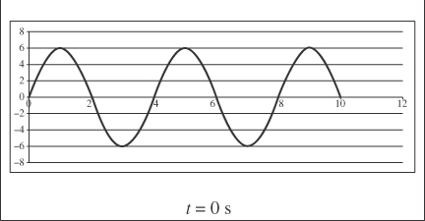  
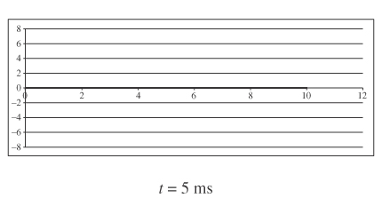  
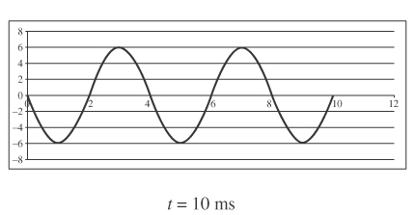  
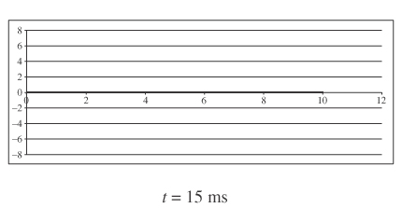  
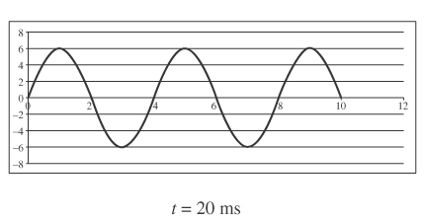**

**ANS. FIG. P17.10**

(b) 

(c) 

(d) 

(e) 

**Section 17.4 Analysis Model: Waves Under Boundary Conditions**

**P17.11** We are given *L* = 120 cm, *f* = 120 Hz.

(a) For four segments, or 

(b)  

**P17.12** (a) Because the string is taut and is fixed at both ends, any standing waves will have nodes (which are multiples of *λ*/2 apart). The wavelengths of all possible modes on the string are:

 where *n* = 1, 2, 3,…

The fundamental (n = 1) wavelength must then have a wavelength *λ* exactly twice the string length, or



(b)  To obtain the frequencies on the string,



it is necessary to have either the wave velocity *v* or the tension T and mass density *µ* of the string. We do not know these; therefore, it is not possible to find the frequency of this mode on the string.

**P17.13** The wave speed is



For a vibrating string of length *L* fixed at both ends, there are nodes at both ends. The wavelength of the fundamental is *λ* = 2*dNN* = 2*L* =   
0.600 m, and the frequency is



After NAN, the next three vibration possibilities read NANAN, NANANAN, and NANANANAN. Each has just one more node and one more antinode than the one before. Respectively, these string waves have wavelengths of one-half, one-third, and one-quarter of   
60.0 cm. The harmonic frequencies are







P17.14 (a) For a standing wave of 6 loops,  or



The speed of the waves in the string is then

**

Since the tension in the string is



 gives



(b) If *m* = 45.0 kg, then



and



Thus, the wavelength will be



and the number of loops is



(c) If *m* = 10.0 kg, the tension is



and



Then,



and  is not an integer,

so 

**P17.15** In the fundamental mode, the string above the rod has only two nodes, at A and B, with an antinode halfway between A and B. Thus,

 or 

Since the fundamental frequency is f, the wave speed in this segment of string is



Because of the pulley, the string has tension T = Mg.

Also,



Thus,

 or 

and the mass of string above the rod is:



**P17.16** In the fundamental mode, the string above the rod has only two nodes, at A and B, with an anti-node halfway between A and B. Thus,

 or 

Since the fundamental frequency is f, the wave speed in this segment of string is



Because of the pulley, the string has tension T = Mg.

Also,



Thus,

 or 

and the mass of string above the rod is:



**P17.17** When the open string vibrates in its fundamental mode it produces concert G. When concert A is played, the shorter length of string vibrates in its fundamental mode also.

(a)   and 



Thus, 

or the finger should be placed .

(b) If the position of the finger is correct within dL = 0.600 cm when the note is played, by how much can the tension be off so that the note is the same? We want to find the maximum allowable percentage change in tension, dT/T, that will compensate for a small percentage change in position, dL/L, so that the change in the fundamental frequency, df, is zero.

From the expression for the fundamental frequency,

 we require df = 0.



**P17.18** Let  represent the mass of the copper cylinder. The original tension in the wire is  The water exerts a buoyant force  on the cylinder, to reduce the tension to



The speed of a wave on the string changes from  to  The frequency changes from

 to 

where we assume *λ* = 2L is constant.

Then



and



**Section 17.5 Resonance**

**P17.19** The wave speed is 

The bay has one end open and one closed. Its simplest resonance is with a node of horizontal velocity, which is also an antinode of vertical displacement, at the head of the bay and an antinode of velocity, which is a node of displacement, at the mouth.

Then, 

and 

Therefore, the period is





**Section 17.6 Standing Waves in Air Columns**

**P17.20** Assuming an air temperature of *T* = 37.0°C = 310 K, the speed of sound inside the pipe is



In the fundamental resonant mode, the wavelength of sound waves in a pipe closed at one end is  Thus, for the whooping crane,



and



**P17.21** (a) The wavelength is 

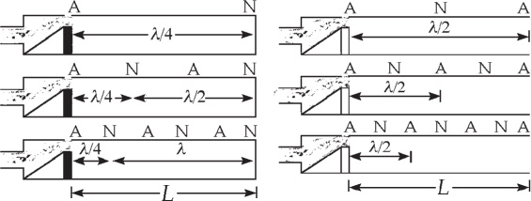

ans. FIG. P17.21

so the length of the open pipe vibrating in its simplest (ANA) mode is



(b) A closed pipe has (NA) for its simplest resonance, (NANA) for the second, and (NANANA) for the third, equal to 5/4 wavelengths.

Here, the pipe length is 

*P17.22 **Conceptualize** Imagine yourself performing the experiment: In an extremely quiet environment, you set the frequency of the sound and then turn its volume up slowly until you can just barely hear it. You then record the physical sound level of the sound from your instrumentation. After performing the experiment, you generate the curve shown in the figure. The curve represents a locus of points all of which have the same *psychological* loudness: you can just barely hear it. It is clear that the sounds vary significantly with frequency in their *physical* measurement, the sound level.

**Categorize** The description of the ear canal as an air column at the end of the problem tells us that we will be using the *waves under boundary conditions* model.

**Analyze** The frequencies of an air column closed at one end are given by Equation 17.10:

 (1)

where *m* is an odd integer beginning at 1: *m* = 1, 3, 5, . . . . The dips in the curve correspond to resonances in the outer ear canal. When a resonance occurs, the sound is a little easier to hear because of the resonance response, so the threshold of hearing drops to a lower value: the sound does not have to be as loud to be detected.

Because there are no dips in the curve at low frequencies, we assume that the dip at 3 800 Hz corresponds to *m* = 1 and the dip at 11 500 Hz to *m* = 3. Solve Equation (1) for *L*, the length of the ear canal:

 (2)

Substitute numerical values for the two dips:



**Finalize** From the average of these results, your ear canal is about 2.25 cm long. Now you are excited about performing the experiment on other people and exploring the variation in lengths of ear canals!

*Answer:* 2.25 cm

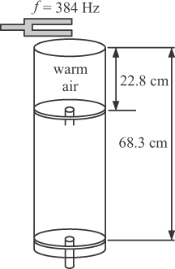**P17.23** For resonance in a narrow tube open at one end,



(a) The node–node distance is

dNN = 68.3 cm – 22.8 cm = 45.5 cm

This distance is equal to half the wavelength, so,

ans. FIG. P17.23



(b) Resonance will be established when the tube length has increased by another half wavelength: 68.3 cm + 45.5 = 113.8 = 

**P17.24** For a closed box, the resonant frequencies will have nodes at both sides, so the permitted wavelengths will be , (*n* = 1, 2, 3, …),

i.e.,  and 

**P17.25**  or for *n* = 1, 2, 3, …

Since ,  for *n* = 1, 2, 3, …

With *v* = 343 m/s and *f* = 680 Hz,

 for *n* = 1, 2, 3, …

Possible lengths for resonance are:



Therefore, with L = 0.860 m, *L*′ = 2.10 m, and *v* = 355 m/s, the resonant frequencies are

 for L = 0.860 m for each n from 1 to 9

and  for *L*′ = 2.10 m for each n from 2 to 23.

**P17.26** (a) The open ends of the tunnel are antinodes, so *dAA* = 2 000 m/*n,* with n = 1, 2, 3,…

Then



and



(b) 

**P17.27** The wavelength of the sound from the tuning fork is . The cylinder is a pipe open at the top and closed at the water surface; its resonance patterns are AN, ANAN, ANANAN, etc. Resonance occurs each time the height of the air column changes by half a wavelength:  The volume of the pipe between these two water levels is  which is also equal to the amount of water that has entered the pipe at rate R in a time interval  and has filled this volume.

Therefore,





**P17.28** The wavelength of the sound from the tuning fork is . The cylinder is a pipe open at the top and closed at the water surface; its resonance patterns are AN, ANAN, ANANAN, etc. Resonance occurs each time the height of the air column changes by half a wavelength:  The volume of the pipe between these two water levels is  which is also equal to the amount of water that has entered the pipe at rate R in a time interval ∆*t* and has filled this volume. Therefore,



**\*P17.29 Conceptualize** When the instrument is brought indoors, the air is warmer than outdoors. As the warm air enters the instrument, the speed of sound of the air in the instrument is higher than it was outside. As a result, the fundamental frequency of the instrument will rise and you will be out of tune with your colleagues.

**Categorize** The sound waves in the instrument are modeled as *waves under boundary conditions.* Standing waves will be set up in the instrument. A flute is an open air column.

**Analyze** Because the flute is an open air column, the fundamental frequency of the instrument is given by Equation 17.9, with *n* = 1:

 (1)

Set up a ratio of the fundamental frequency in the warm room to that in the cold outside air:

 (2)

where we have incorporated the assumption that *L* does not change with temperature. Now, use Equation 16.36 to substitute for the speed of sound as a function of temperature:

 (3)

Solve Equation (3) for the temperature *T*cold outside the auditorium:

 (4)

Substitute numerical values:



**Finalize** It is certainly possible for a winter day to be this cold; it is very important that you tune your instrument in the same air in which you will be playing it! Interestingly, if stringed instruments are tuned in the cold air and then played in warmer air, their frequencies go *down*. The strings tend to expand in the warmer air, reducing the tension in the string, and thereby reducing the fundamental frequency.

*Answer:* *fn* = *n*(0.200 Hz)

**P17.30** For an air column of length 0.730 m, the column may be open ended or closed at one end. For a column open at both ends:

 where n = 1, 2, 3,…

 where n = 1, 2, 3,…

And thus 235 Hz belongs to the harmonic series of an open column (with n = 1), but 587 Hz does not match this harmonic series. Similarly, for a column open only at one end:

 where n = 1, 3, 5,… (only odd harmonics)

 where n = 1, 3, 5,...

and 587 Hz belongs to the harmonic series of a column open at only one end (for n = 5), but 235 Hz does not match this harmonic series. Therefore, it is impossible because a single column could not produce both frequencies.

**Section 17.7 Beats: Interference in Time**

**P17.31** The source moves toward the wall:

*v*s = +*v*student, *v*0 = 0, and 

The wall acts as stationary source, reflecting the wave of frequency  The observe moves toward the source: *v*s = 0, *v*0 = +*v*student, and



(a) When the student walks toward the wall  is larger than *f*; the beat frequency is





(b) When he is moving away from the wall, the sign of *v*student changes and  is smaller than f:



Solving for *v*student gives



**P17.32** (a) The string could be tuned to either  from this evidence.

(b) Tightening the string raises the wave speed and frequency. If the frequency were originally 521 Hz, the beats would slow down.

Instead, the frequency must have started at 525 Hz to become .

(c) From ,

 and 

The fractional change that should be made in the tension is then

fractional change 



The tension should be 

**Section 17.8 Nonsinusoidal Waveforms**

**P17.33** We evaluate



where *s* represents particle displacement in nanometers and *θ* represents the phase of the wave in radians. As *θ* advances by 2*π*, time advances by (1/523) s. The resultant waveform is shown below in ANS. FIG. P17.33.

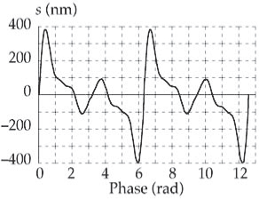

ans. FIG. P17.33

**Additional Problems**

**P17.34** The beat frequency between the waves emanating from the two strings is



and, because the decrease in tension causes the second frequency to be lower,



**P17.35** At point D, the distance of the ship from point *A* is



Since destructive interference occurs for the first time when the ship reaches *D*, it is necessary that  or



**P17.36** According to Equation 18.6, the natural frequencies of vibration of a string fixed at both ends are given by



where n = 1, 2, 3, ...

(a) 

(b) This could be any mode that has a node 0.400 m from an end. If   
D = 0.400 m is the distance between adjacent nodes (the distance across a pair of nodes),  and its wavelength is   
0.800 m:



This mode corresponds to the 5th harmonic: *f*5 = 5(5.00 Hz) =   
25.0 Hz. But D could be the distance across two pairs of nodes (from node to node to node), , or three pairs, *d*NNN, or across N pairs of nodes:



then,



and so on, corresponding to the 10th, or the 15th harmonic, etc.



**P17.37** (a) The frequency of the normal mode produces a sound wave of the same frequency. For the same frequency, wavelength is proportional to wave speed. On the string, the wave speed is



which is smaller than the speed of sound (343 m/s).

The wavelength in air of the sound produced by the string is  because the wave speed is larger.

(b) 

**\*P17.38** **Conceptualize** The water in the basin is a wave medium with boundaries: the ends of the basin, at which reflections of water waves will occur. Therefore, the possibility of standing waves exists. Consider the left side of Figure 17.17a, which shows standing waves in an air column open at both ends. The seiche standing waves in a basin will be similar, because the water at the boundaries is free to move. The curves on the left in Figure 17.17a would represent the height of the water for a seiche.

**Categorize** Because we are dealing with standing waves, we use the *waves under boundary conditions* model. The standing wave patterns will have antinodes at each end of the water basin. In addition, the text of the problem discusses a pulse moving across the water in your friend’s basin, which can be described by the *particle under constant velocity* model.

**Analyze** Consider the lowest possible mode of vibration, which would be similar to the sound wave for the first harmonic of the open air column in Figure 17.17a. The length of the water basin would be related to the wavelength of the wave as follows:

 (1)

Now consider the measurement of the time interval required for a pulse to travel across the water in your friend’s basin. From the particle under constant velocity model,

 (2)

where *v* is the speed of waves across the water surface and *t* is the time at which the pulse arrives at position *xf* = *L* if it was at *xi* =0 at *t* = 0. Using Equation 16.12, find the frequency of the first harmonic for a seiche in the pond, using Equations (1) and (2):



Substitute the numerical value:



This frequency is definitely in the range 0–4 Hz given in the problem statement. In addition, higher modes of oscillation will have frequencies that are integer multiples of this fundamental frequency: *fn* = *n*(0.200 Hz).

**Finalize** As a result, there will be several resonance frequencies in the range 0–4 Hz, and you should insist that the architect listen to your objections to the proposed plan. Notice that we needed to introduce a length *L* of the basin to perform the algebraic calculations, but we never needed to know its value because it canceled in the final equation.

Answer: *fn* = *n*(0.200 Hz)

**P17.39** (a) The tension on the string defines the wave velocity on the string, and thus also the frequencies, wavelengths, and number of nodes of the standing waves. The tension on the string in Figure 18.11a is:

 where m is the mass of the sphere.

The tension on the string in Figure 17.15b, must also include the buoyant force on the sphere:



Notice that the number of antinodes *n* is exactly the number of half wavelengths of standing waves on the string (i.e. there are two antinodes (and one full wavelength) on the string in Figure 17.15a, and there are five antinodes (and two and a half full wavelengths) in Figure 17.15b). From Equations 17.6 and 17.7 we have



The frequency of oscillation is the same in both cases because it is defined by the moving blade to the left. In addition, neither the total length of the string L nor the string density *µ* changes between the two cases:

 and 

therefore,



Or equivalently,



But we have already obtained the value for tension above in terms of the buoyant force and thus the radius of the sphere.



The radius of the sphere *r* may now be solved in terms of the number of antinodes *n*2 (and the other parameters, *n*1, m, g, and  which are all constants, or already defined in the problem).



solving for *r* gives



where *r* is in meters.

(b) Because the factor inside the cube root



will be either zero or negative, which are each meaningless results, for n = 1 and 2, the minimum allowed value of *n* for a sphere of nonzero size is 

(c) Because the mass of the sphere is held constant, while its radius (and thus also volume and density) is changed, there will reach a point where the density of the sphere reaches the density of water, and thus the sphere will float, so that it will no longer be fully immersed in the water. After this point, the sphere will float on the water, and will not produce further standing waves.

The limiting condition is 

But  which may be rearranged to solve for r.



and substituting in numerically:



is the limiting (maximum) radius for which the sphere will stay totally immersed.

(d) 

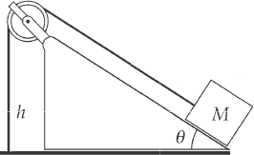**P17.40** (a) 

(b) 

(c) For the block:

ans. FIG. P17.40



so 

(d) The length of the section of string parallel to the incline is  The total length of the string is then



(e) The mass per unit length of the string is



(f) The speed of waves in the string is



(g) The fundamental mode vibrates at the lowest frequency. In the fundamental mode, the segment of length h vibrates as one loop. The distance between adjacent nodes is then  so the wavelength is 

The frequency is 

(h) 



(i) The fundamental mode has a wavelength twice the length of the sloped section of string,  Its frequency is



**P17.41** (a) Use the Doppler formula:



with  frequency of the speaker in front of student and

 frequency of the speaker behind the student.



Therefore, .

(b) The waves broadcast by both speakers have



The standing wave between them has 

The student walks from one maximum to the next in time

 so the frequency at which she hears maxima is



**P17.42** We are told that the man’s ears are at the same level as the lower speaker. Sound from the upper speaker is delayed by traveling the extra distance 

He hears a minimum when  with *n* = 1, 2, 3, …

Then,





 **[1]**

Equation [1] gives the distances from the lower speaker at which the man will hear a minimum. The path difference  starts from nearly zero when the man is very far away and increases to *d* when *L* = 0.

(a) The number of minima he hears is the greatest integer value for which  This is the same as the greatest integer solution to



or



(b) From equation [1], the distances at which minima occur are given by



**P17.43** We use the basic relationship 

(a) Changing the length does not change the tension or the mass per unit length, so the wave speed is the same.



The  to get the same number of antinodes for twice the length.

(b)  so 

The tension must be 

(c)  so 

  to get twice as many antinodes.

**P17.44** (a) The wavelength is twice the length of string from the top end to the yo-yo: *λ* = 2L. The length *L* changes in time because the yo-yo is a particle under constant acceleration:  where *L*0 is the length of the string at t = 0 and *a* is the acceleration of the yo-yo. Therefore,



(b) For the second harmonic, the wavelength is equal to the length of the string. Therefore,



(c) 

(d) 

**P17.45** As in Problem 18, we let  represent the mass of the copper cylinder. The original tension in the wire is  The water exerts a buoyant force  on the copper object, where *n* is the fraction of the object that is submerged, to reduce the tension to



The speed of a wave on the string changes from  to  The frequency changes from



where we assume *λ* = 2L is constant.

Then



and



The frequency decreases as the fraction of the object that is submerged increases, with the lowest frequency occurring when the object is completely submerged, or *n* = 1:



**P17.46** The wavelength stays constant at  while the wavespeed rises according to



so the frequency rises as 

The number of cycles is N = dt/T = f dt in each incremental bit of time, or altogether



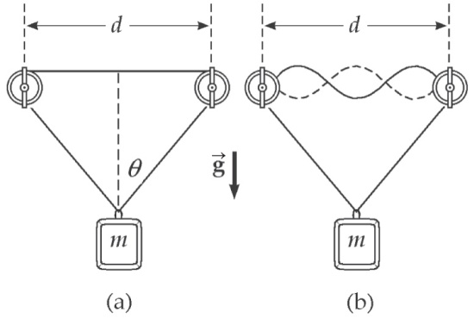**P17.47** (a) Let *θ* represent the angle each slanted rope makes with the vertical. In the diagram, observe that:



or 

ans. FIG. P17.47

Considering the mass,



or 

(b) The speed of transverse waves in the string is



For the standing wave pattern shown (3 loops), 

or 

Thus, the required frequency is 

**P17.48** (a) Let *θ* (refer to ANS. FIG. P17.48) represent the angle each slanted rope makes with the vertical. In the diagram, observe that:



and



Considering the mass,



or 

(b) The speed of transverse waves in the string is 

For the standing wave pattern shown (3 loops), 

or 

Thus, the required frequency is 

**P17.49** We look for a solution of the form

5.00 sin (2.00*x* – 10.0t) + 10.0 cos (2.00*x* – 10.0t)

= A sin (2.00*x* – 10.0t + *φ*)

= A sin (2.00*x* – 10.0t) cos *φ* + A cos (2.00*x* – 10.0t) sin *φ*

This will be true if both 5.00 = A cos *φ* and 10.0 = A sin *φ*, requiring

 and



(a) 

(b) From above  and .

**Challenge Problem**

**P17.50** Equation 16.41 is



(a) Multiplying by sin m*ω*t gives:



Integrating over one period *T* gives:

 [1]

Inspecting the left-hand side of the equation, we note that y(t) is a positive constant A for half of the period T, and an equal but negative constant –A for the other half period:



If we look at the first of the two integrals on the right:



which gives different answers depending on whether *m* is even or odd:

If m is odd: 

If m is even: 

(because we are integrating over half periods).

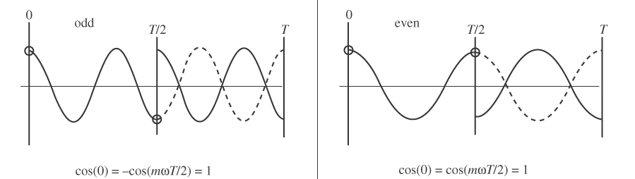

(a) (b)

ans. FIG. P17.50

The second of the two integrals on the right gives a similar result:



Thus,



Putting everything together, we have shown that



(b) We can analyze the terms involving *Bn* on the right hand side of eqn. [1] above:



Using the trigonometric identity



we have



The sine function, whether the terms are (n + m) or (n – m), it will always integrate to zero over any full multiple of a period:



Thus, all the terms involving *Bn* on the right hand side of eqn. [1] are equal to zero:



(c) For all the terms on the right hand side of eqn.(1) with *An*:



Using the trigonometric identity



we have



which can be integrated and evaluated at 0 and T:



The second term, when evaluated at 0 and T, always gives zero. The same is true for the first term for all values of n except where n = m. Thus, all the terms on the right hand side of eqn. (1) with *An* are zero except when m = n.

(d) For n = m, we will do the integration separately:



Thus, the entire right side reduces to 

(e) Starting with our original Equation 16.41:



notice that y(t) is an odd function of t: y(t) = –y(t), and the sine function is also odd, but the cosine function is even. From these observations, we can conclude that there are no cosine terms in the Fourier series expansion of y(t); therefore, all the *Bn* = 0. Thus,



But we have shown in part (a) above that:



where m must be odd, and in part (d) that:



where n = m.

Thus, for each *An* term: . And because 



which we substitute in to give:



where the summation is only over odd values of *n*.

|  |
| --- |
| **ANSWERS TO QUICK-QUIZZES** |

**1.** (c)

**2. (i)** (a) **(ii)** (d)

**3.** (d)

**4.** (b)

**5.** (c)

|  |
| --- |
| **ANSWERS TO EVEN-NUMBERED PROBLEMS** |

**P17.2** (a) See ANS. FIG. P17.2 (a-e); (b) See ANS. FIG. P17.2(f-j)

**P17.4** The man walks only through two minima; a third minimum is impossible.

**P17.6** (c) Yes; the limiting form of the path is two straight lines through the origin with slope 6 0.75**.**

**P17.8** See P17.8 for full verification.

**P17.10** (a) See ANS. FIG. P17.10; (b) In any one picture, the wavelength is the smallest distance along the *x* axis that contains a nonrepeating shape. The wavelength is *λ* = 4 m; (c) The frequency is the inverse of the period. The period is the time the wave takes to go from a full amplitude starting shape to the inversion of that shape and then back to the original shape. The period is the time interval between the top and bottom graphs: 20 ms. The frequency is 1/0.020 s = 50 Hz; (d) 4 m. By comparison with the wave function., we identify  and then compute  (e) 50 Hz. By comparison with the wave function, we identify .

**P17.12** (a) 5.20 m; (b) No. We do not know the speed of waves on the string.

**P17.14** (a) 4.90 × 10–3 kg/m; (b) 2; (c) no standing wave will form

**P17.16** 

**P17.18** 291 Hz

**P17.20** 57.9 Hz

**P17.22** 2.94 cm

**P17.24** *n*(206 Hz) and *n*(84.5 Hz)

**P17.26** (a) 0.085 8*n* Hz, with *n* = 1, 2, 3 . . . ; (b) It is a good rule. A car horn would produce several or many of the closely-spaced resonance frequencies of the air in the tunnel, so it would be great amplified.

**P17.28** 

**P17.30** It is impossible because a single column could not produce both frequencies.

**P17.32** (a) 521 Hz or 525 Hz; (b) 526 Hz; (c) reduced by 1.14%

**P17.34** 146 Hz

**P17.36** (a) 5.0 Hz, 10.0 Hz, 15.0 Hz; (b) The frequency could be the fifth state at 25.0 Hz or any integer multiple, such as the tenth state at 50.0 Hz, the fifteenth state at 75.0 Hz, and so on.

**P17.38** (a) 3.66 m/s (b) 0.200 Hz

**P17.40** (a) the particle under constant acceleration model; (b) waves under boundary conditions model; (c)  (d) ;   
(e) ; (f) ; (g) ; (h) 121 Hz; (i) 60.6 Hz

**P17.42** (a) ;   
(b) 

**P17.44** (a) = 1.92 m/s; (b) 0.960 m/s, half as much as for the first harmonic; (c) Yes. A yo-yo of different mass will hold the string under different tension to make each string wave vibrate with a different frequency, but the geometrical argument given in part (a) still applies to the wavelength; (d) Yes, for the same reason as (c); the geometrical argument given in part (b) still applies to the wavelength.

**P17.46** 407 cycles

**P17.48** (a) ; (b) 

**P17.50** (a) see P17.50(a) for full explanation; (b) see P17.50 (b) for full explanation; (c) See P17.50 (c) for full explanation; (d) see P17.50 (d) for full explanation; (e) see P17.50 (e) for full explanation.